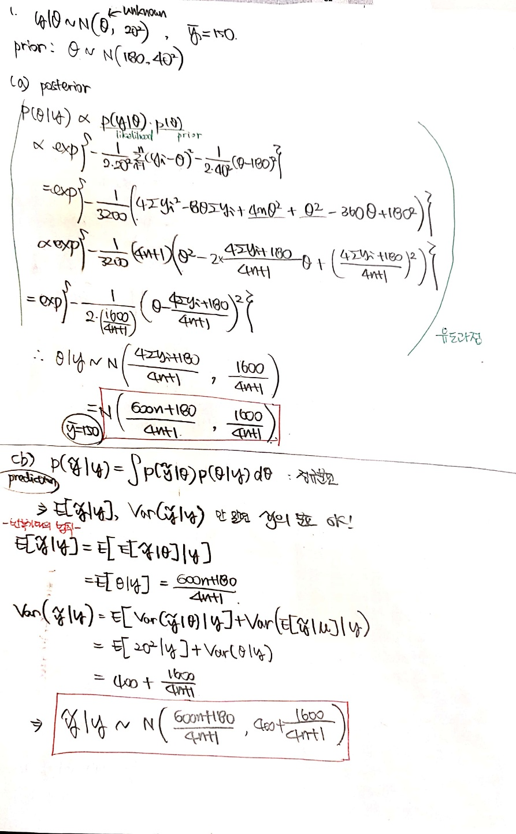

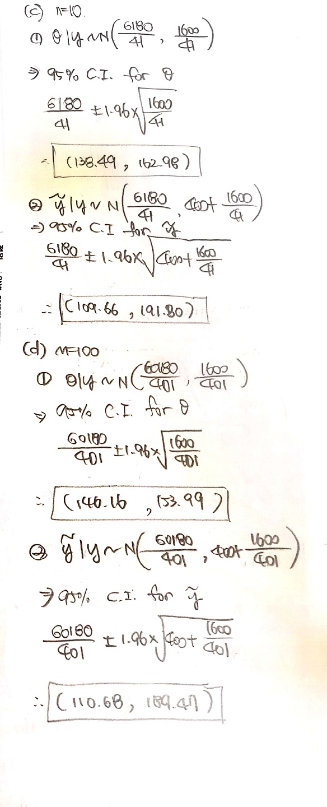

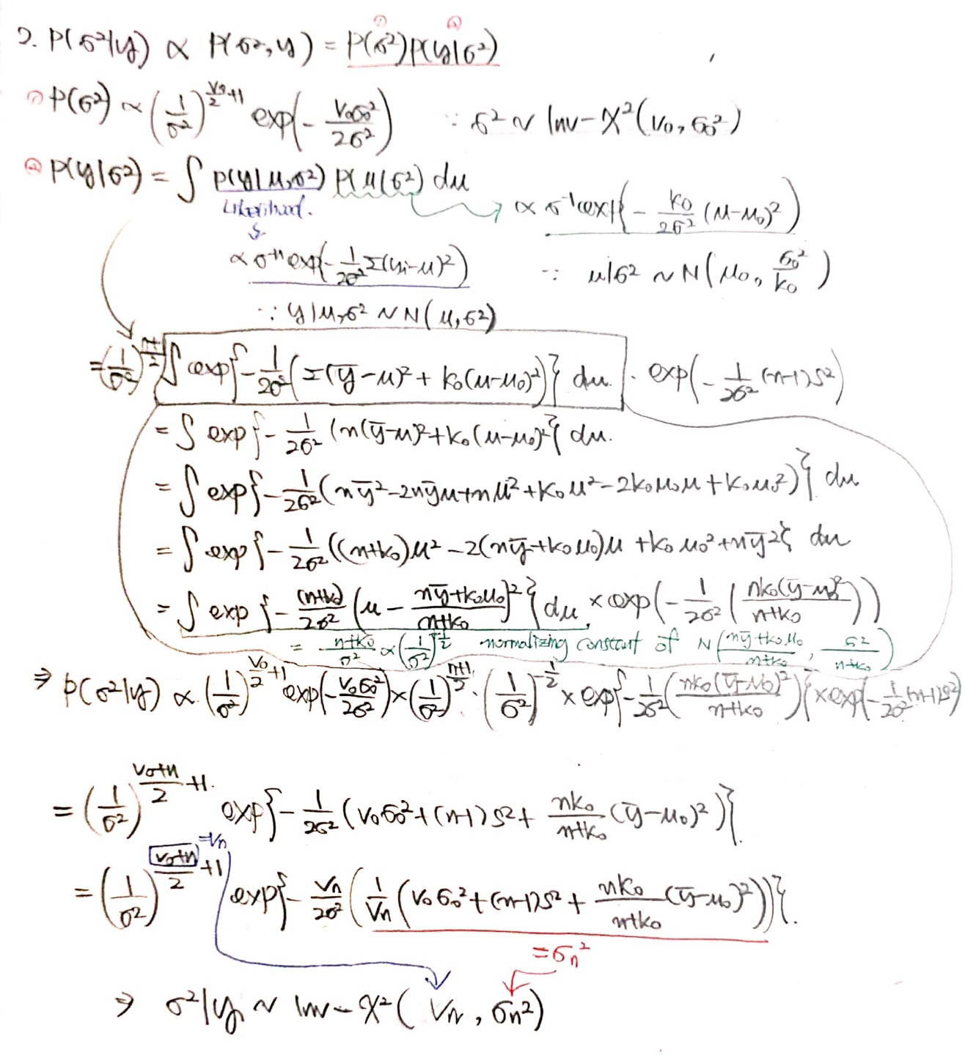

## Normal model with unknown mu

* data) mu = 5(모른다 가정), sd = 2.5, n = 10
* prior) mu_0 = 10, tau_0 = 5 (normal)

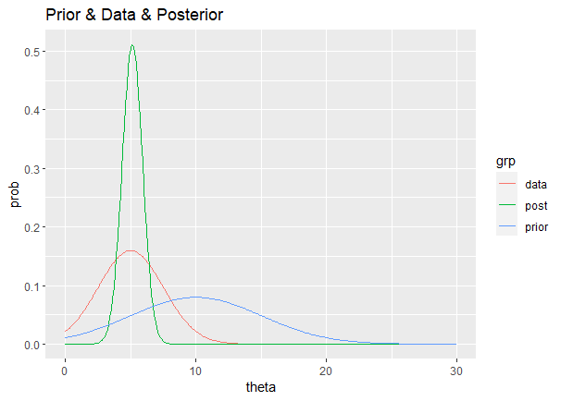

## Normal model with unknown sigma

* data) mu = 5(모른다 가정), sd = 2.5, n = 10
* prior) sigma_0 = 2, nu_0 = 9 (inverse chi-square)

